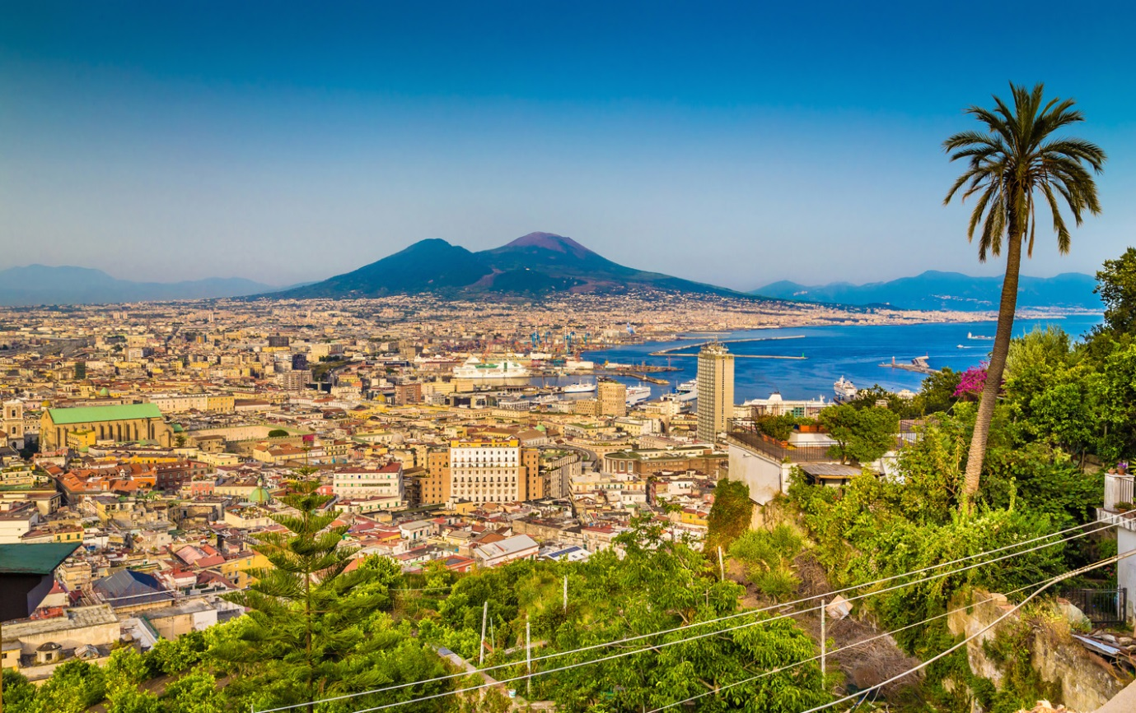

ITALY PACKING LIST:
Clothing:
- Walking Boots/ Sturdy footwear: these should have a strong grip to cope with the conditions, which may be steep and uneven with loose stones and scree.
- Layered clothing: lightweight tops, trousers and fleeces/ jumpers. Female travellers may find a shawl useful.
- Outerwear: a light waterproof jacket is recommended.
- Sleepwear: hotel accommodation is of a good standard and rooms are warm and comfortable. Pyjamas are adequate.
- Swimming suit and towel
- Reef shoes or jelly shoes: to protect your feet against sharp rocks when on the beaches in Sicily or using the thermal pools on Vulcano island.
General Items:
- Day bag/ rucksack: we recommend a rucksack or backpack, as these are far more suitable for trekking and walking than a shoulder bag or satchel.
Field Study equipment: as determined by the school/ college.
- Sun protection: please remember to bring a sunhat, sunglasses and a good sun cream
- Insect repellent
- Lip balm and moisturiser
- Camera and batteries
- Power adaptors
Other:
- Glasses: should you wear contact lenses then we recommend bringing a spare pair of glasses as dusty conditions can make wearing lenses very uncomfortable.
Medication:
Please remember to bring any medication required during your stay. Over-the-counter and prescription medicines may require a doctor’s letter confirming that the drugs are medically required and have been obtained legally. Please contact the relevant Embassy of the country you are travelling to in order to check transportation rules before travel.
Luggage:
We recommend taking as little as possible whilst ensuring you have sufficient to enjoy your trip. Taking too much luggage can be a nuisance, especially if you exceed luggage allowance limits on the flight, or wish to buy souvenirs to bring home.
It is recommended that both students and teachers are able to comfortably carry their luggage themselves.

